Chapter 11, Problem 34.
Find the effective value of f(t) defined in Fig. 11.65.

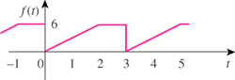

Figure 11.65
For Prob. 11.34.

